Deborah Barndt

ITMD 566 Service-Oriented Architectures

Professor Hosea Lee

Twitter Service

2-11-19

In this assignment, we will consume a Twitter service and display the output of the service in our website. For this project, I will provide several php files to help this implementation. However, since these files are php files, you will need a webserver with php feature to make this work. I will explain this during next class for those who do not know how to setup a web server with php.  
1. copy the attached files to the root directory of your web server

2. take a screenshot of phpinfo.php (just first page) - 10 points

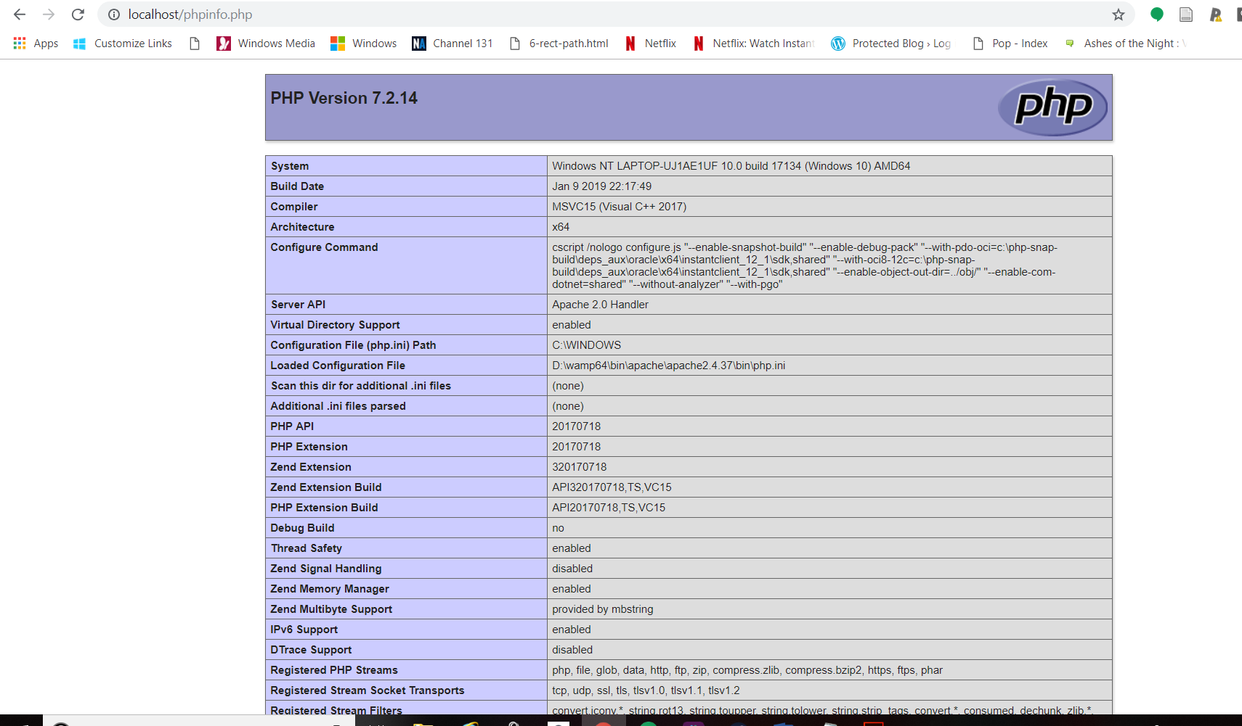

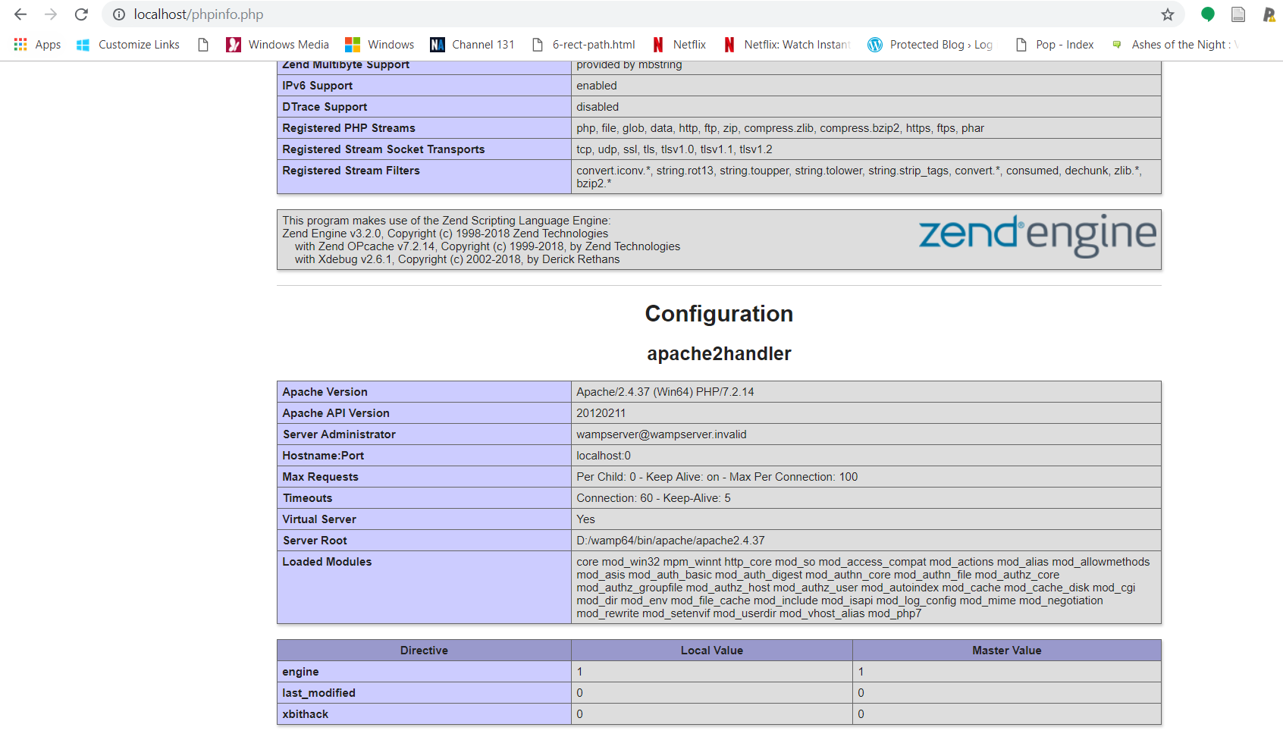

3. take a screenshot of the output of the tweets on the browser (http://localhost/yourname.html - make sure to change the file name with your full name). The screenshot must include the url as well - 10 points

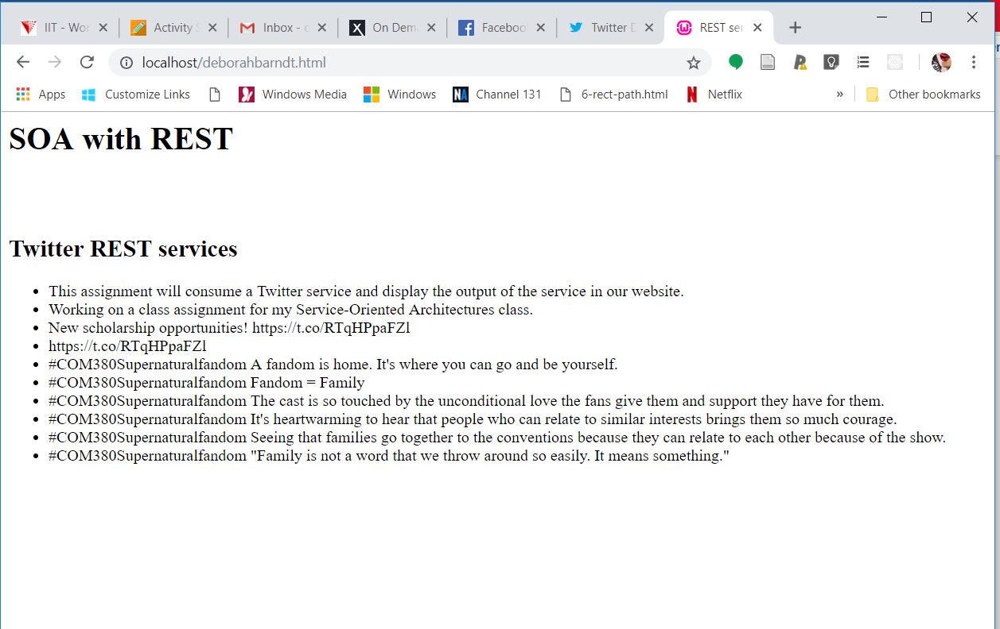

4. take a screenshot of your twitter app keys and tokens - 10 points

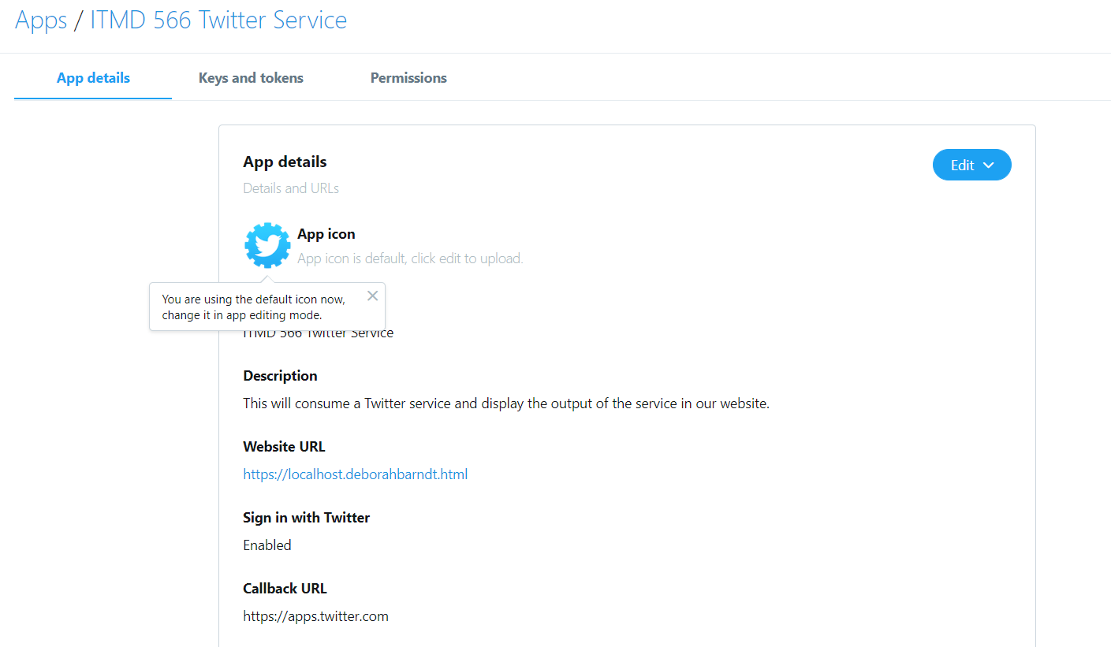

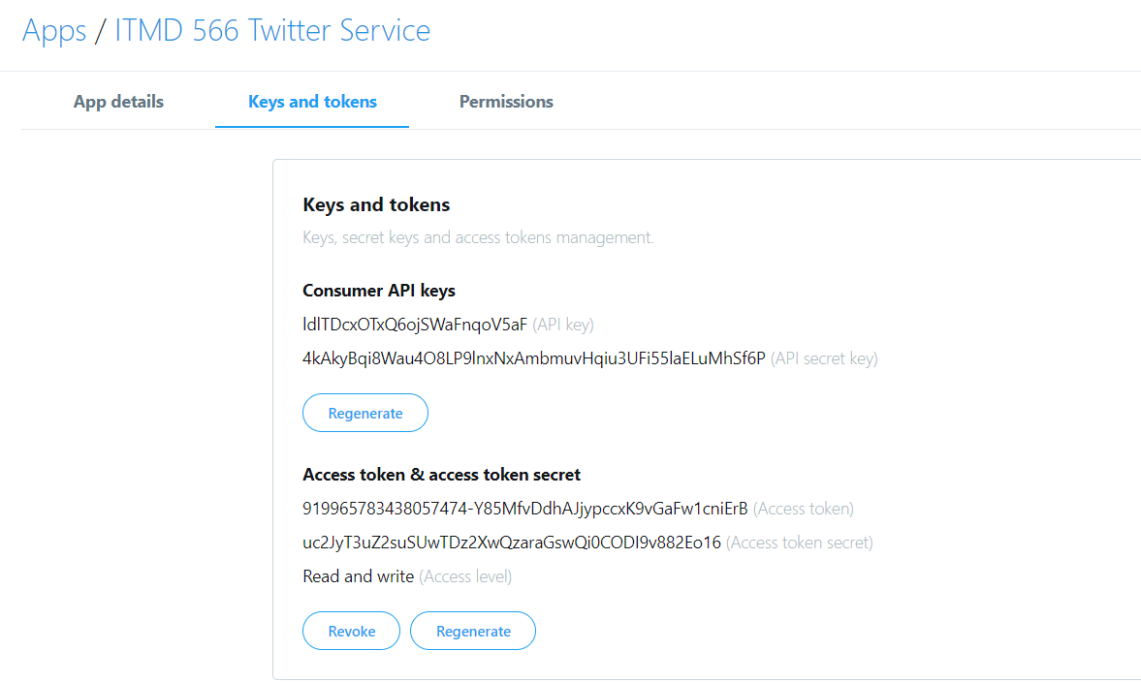

5. submit in PDF format with the screenshot images

\*\* extra credit available for additional service implementation \*\*